**DATA SCIENCE COURSE**

**Assignment # 01**

Q no : 01

Answer **:**

**Code:**

print ('''Twinkle, twinkle, little star

How I wonder what you are

Up above the world so high

Like a diamond in the sky

Twinkle, twinkle, little star

How I wonder what you are''')

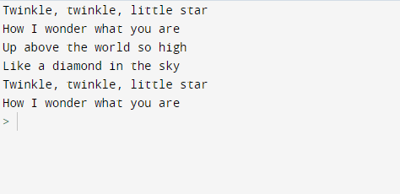**Output :**

**Qno #02**

**Answer :**

**CODE :**

import sys

print ("python version")

print (sys.version)

**OUTPUT :**

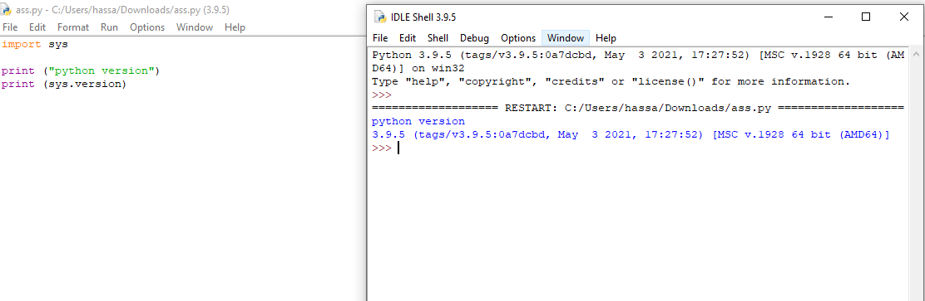

**Qno #03**

**Answer :**

**CODE:**

import datetime

now = datetime.datetime.now()

print("Current Date And Time is:")

print(now.strftime("%d-%m-%y %H:%M:%S"))

**OUTPUT :**

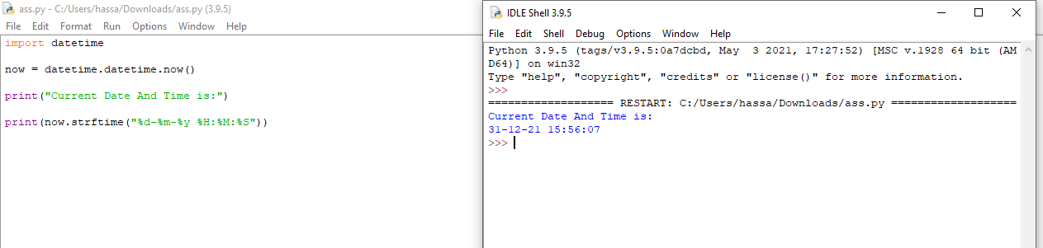

**Qno #04**

**Answer :**

**CODE:**

import math

radius = float(input("Enter the Radius of the circle : "))

area = math.pi * radius * radius

print("Area of the Circle is : {0}".format(area))

**OUTPUT :**

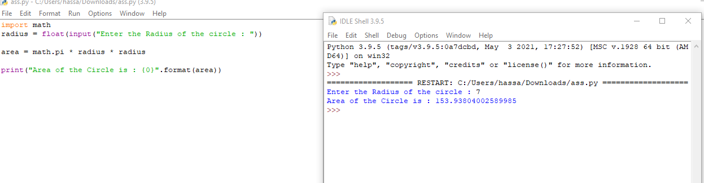

**Qno #05**

**Answer :**

**CODE :**

firstName = input("Enter your First Name: ")

lastName = input("Enter Your last Name: ")

print("Hello:" + lastName + " " + firstName)

**OUTPUT :**

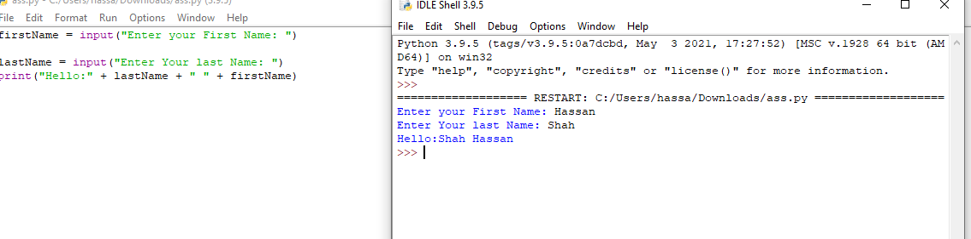

**Qno #06**

**Answer :**

**CODE :**

a=int(input("enter first number : "))

b=int(input("enter second number : "))

print("sum of",a, "and",b,"is",a+b)

**OUTPUT :**

